PERFORMANCE TESTING REPORT
AgriBot — Smart Agriculture Platform (agribot.sbs)
Prepared by: Matrix | Role: Junior Quality Assurance Analyst | Week 4 Deliverable

1. Introduction
This report documents a performance testing exercise conducted against AgriBot, a live smart-agriculture web application hosted on an AWS EC2 instance. Unlike functional testing (covered in Weeks 1–3), performance testing evaluates how the application behaves under concurrent user load — specifically response time, throughput, and error rate — rather than whether individual features work correctly.
Apache JMeter was used as the load-generation tool, simulating multiple concurrent virtual users making HTTP requests against three real pages: the Homepage, the About page, and the Login page.

2. Objectives
- Measure baseline response time under light load before scaling up.
- Measure response time, throughput, and error rate under a realistic concurrent load (50 users).
- Compare performance across pages of differing weight (media-heavy Homepage vs. lightweight About/Login pages).
- Identify potential bottlenecks and recommend improvements based on observed data.

3. Test Environment
Item | Detail
Application Under Test | AgriBot (https://agribot.sbs)
Hosting | AWS EC2 instance (personal deployment, not production-grade high-availability infrastructure)
Load Testing Tool | Apache JMeter
Pages Tested | Homepage (/), About page (/about), Login page (/login)
Test Machine | Local Windows machine running JMeter GUI, connecting over the public internet to the live site

4. Test Plan
Two test sessions were designed and executed using JMeter's Thread Group configuration, listed below. Load was intentionally increased in stages (5 users → 50 users) rather than jumping straight to a high load, both to establish a clean baseline and to avoid overwhelming a personal, non-production EC2 instance.
Test | Threads (Users) | Ramp-up | Loop Count | Page(s) Tested | Purpose
Test 1: Baseline | 5 | 10s | 5 (25 samples) | Homepage | Establish a light-load baseline before scaling up
Test 2: Load Test | 50 | 10s | 2 (100 samples/page) | Homepage, About, Login | Evaluate behaviour under realistic concurrent load, compared across pages

4.1 Success Criteria
- Error rate should remain at 0% — the application should not fail requests under the tested load.
- Average response time should remain under 1 second for a reasonable user experience.
- Response time should not increase disproportionately as load increases (a sign of a scaling bottleneck).

5. Test Execution & Results
Both test sessions completed with a 0.00% error rate across all requests — AgriBot did not return any failed, timed-out, or errored responses at either load level tested. Full results are summarised below.
Page | Load | Samples | Avg (ms) | Min (ms) | Max (ms) | Std Dev | Error % | Throughput
Homepage | 5 users | 25 | 453 | 154 | 1733 | 332.80 | 0.00% | 7.5/min
Homepage | 50 users | 100 | 421 | 120 | 919 | 226.68 | 0.00% | 9.2/sec
About page | 50 users | 100 | 254 | 120 | 1079 | 191.43 | 0.00% | 9.6/sec
Login page | 50 users | 100 | 188 | 120 | 869 | 128.02 | 0.00% | 9.6/sec

6. Analysis

6.1 Response Time by Page (50 Concurrent Users)
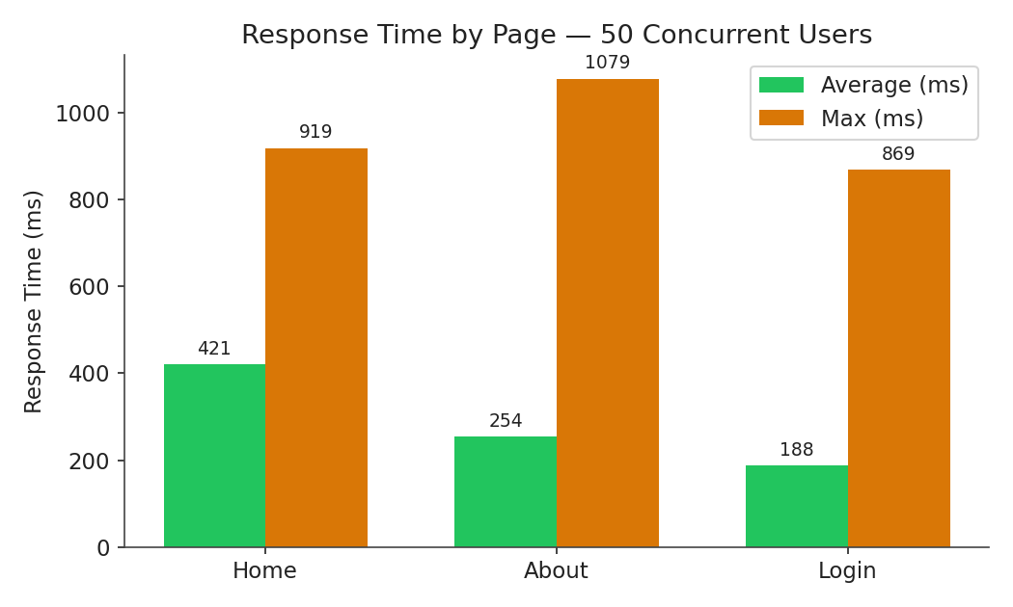
Figure 1 — Average and maximum response time per page under 50 concurrent users.
At the same load level, the three pages show clearly different performance profiles. The Login page was fastest and most consistent (188ms average, 869ms max), followed by the About page (254ms average), with the Homepage slowest (421ms average, and the highest maximum of any page at 919ms). This ordering matches the relative weight of each page: the Homepage loads an autoplaying background video plus several external resources (Tailwind CSS CDN, Font Awesome, Google Fonts, and the AOS animation library), while the About and Login pages are comparatively lightweight.

6.2 Baseline vs. Load: Does Performance Degrade Under Load?
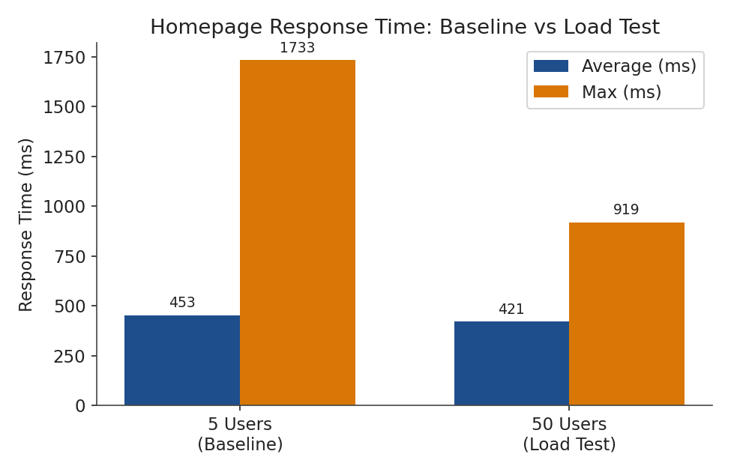
Figure 2 — Homepage response time at 5 users (baseline) vs. 50 users (load test).
Counter-intuitively, the Homepage's average response time was slightly lower under the 50-user load test (421ms) than in the 5-user baseline (453ms), and the maximum response time dropped substantially, from 1,733ms down to 919ms. This is most plausibly explained by a “cold start” effect: the baseline test was likely the first set of requests hitting the server (and any caching layer) after a period of inactivity, causing the first few requests to be unusually slow. By the time the 50-user test ran, the server, and any cached static assets, were already “warm,” producing more consistent results despite the substantially higher concurrent load.
This is a meaningful finding in its own right: it suggests AgriBot's EC2 instance handles sustained concurrent load reasonably well once warmed up, but may show slower response times on a genuinely cold first request — relevant for real users arriving after a period of low traffic.

6.3 Consistency Across Pages
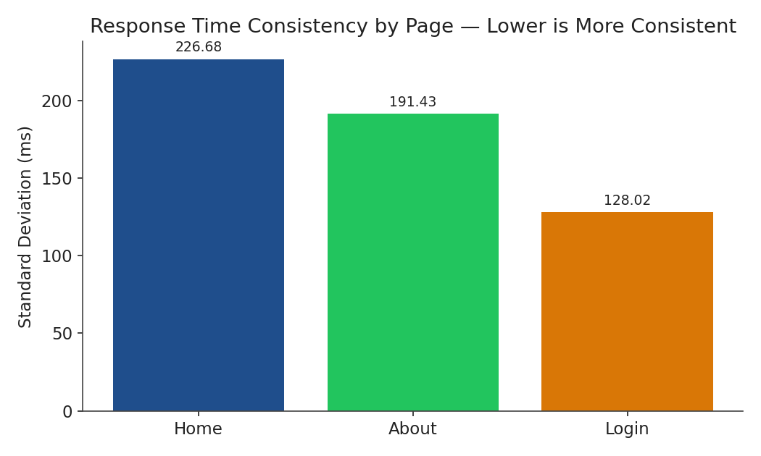
Figure 3 — Standard deviation of response time per page (lower = more consistent).
Standard deviation — how much individual response times varied around the average — followed the same pattern as average response time. The Homepage had the highest variability (226.68ms), meaning some requests were notably slower than others, while the Login page was the most consistent (128.02ms). This further supports the Homepage's heavier asset load as the primary source of variability, since a lightweight page has fewer opportunities for a slow external resource to delay the overall response.

7. Bottleneck Analysis
- Primary bottleneck: the Homepage's reliance on multiple external CDN resources (Tailwind CSS, Font Awesome, Google Fonts, AOS) and an autoplaying video. Each of these is an additional network round-trip that the lighter pages don't require, and any one of them being briefly slow disproportionately affects the Homepage's overall load time.
- Secondary factor: a likely “cold start” effect on the very first requests to a page after a period of inactivity, consistent with the higher baseline maximum (1,733ms) compared to the warmed-up load test maximum (919ms).
- No evidence of a server-side capacity bottleneck was found at the load levels tested: error rate remained at 0.00% even at 50 concurrent users, and response times did not increase disproportionately as load increased — in fact they improved slightly once warmed up. This suggests the EC2 instance has more headroom above 50 concurrent users, which was not explored in this round of testing given the constraints of testing against a live, personal-tier deployment.

8. Recommendations
- Bundle and minify external CSS/JS dependencies (Tailwind, Font Awesome, AOS) rather than loading them from third-party CDNs at runtime, or self-host them, to reduce the number of external round-trips the Homepage depends on.
- Consider lazy-loading the autoplaying background video (e.g. load it after the rest of the page has rendered) so it does not contribute to the page's initial response/render time.
- Investigate a lightweight caching layer (e.g. a reverse proxy cache or CDN in front of EC2) to reduce the impact of the observed cold-start effect on first-time visitors.
- Repeat this test at higher concurrency (e.g. 100–200 users) in a controlled window to establish AgriBot's actual breaking point, since 0% errors at 50 users suggests there is unused headroom that this round of testing did not reach.
- Re-run this same test plan periodically (e.g. after significant feature additions) to catch performance regressions early, using this report's figures as a baseline for comparison.

9. Conclusion
AgriBot handled both tested load levels (5 and 50 concurrent users) with a 0.00% error rate, indicating the application is stable under moderate concurrent load. The Homepage was consistently the slowest and most variable page, attributable to its external CDN dependencies and autoplaying video rather than any apparent server-side capacity issue. The Login and About pages performed quickly and consistently at the same load level, confirming that AgriBot's core, lightweight workflows scale well. The main opportunity for improvement lies in reducing the Homepage's external resource dependencies rather than server infrastructure changes, alongside further testing at higher concurrency to establish the application's true breaking point.

Appendix A: Infrastructure Evidence
The following evidence confirms these tests were executed against a real, deployed AWS EC2 instance rather than a local or simulated environment.

A.1 EC2 Instance Details
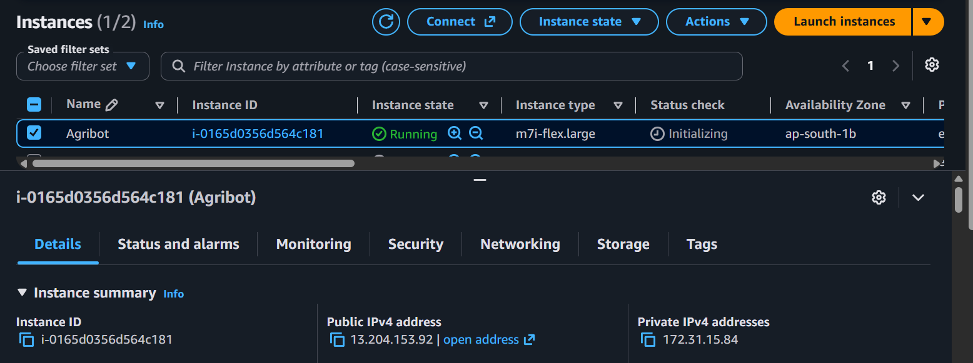
Figure 4 — AWS EC2 Console showing the running “Agribot” instance (m7i-flex.large, ap-south-1b), the same instance serving https://agribot.sbs.

A.2 Running Application Containers
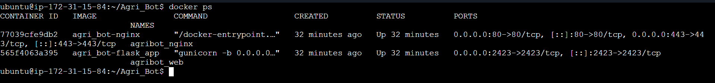
Figure 5 — docker ps output on the EC2 instance, showing the Nginx reverse proxy and the Gunicorn/Flask application containers both up and serving traffic on ports 80/443/2423.

A.3 Live Request Logs During Testing
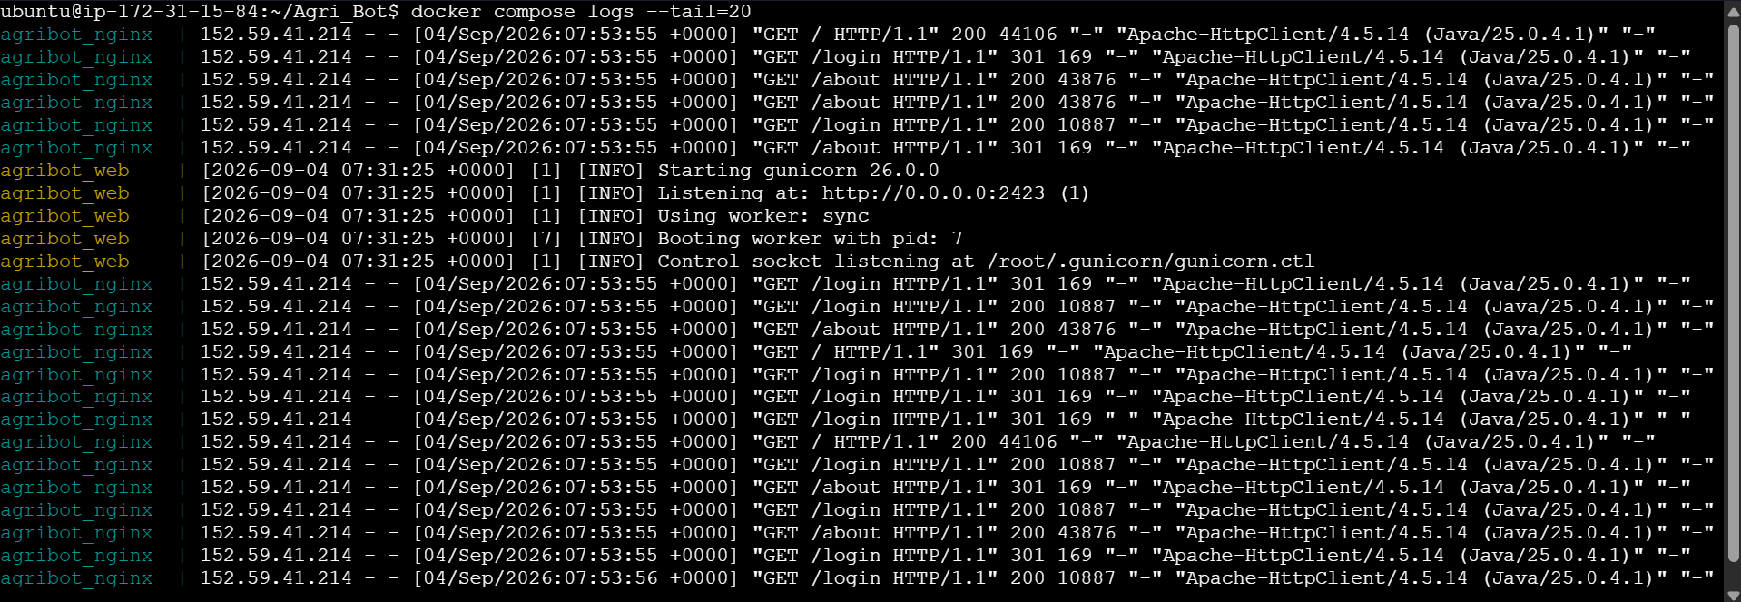
Figure 6 — docker compose logs on the EC2 instance, showing real Nginx access log entries for /, /login, and /about with HTTP 200/301 responses. The User-Agent “Apache-HttpClient (Java)” on each request line is JMeter's own client signature, confirming these requests originated from the load test rather than manual browsing.
Together, these logs corroborate the Summary Report data in Section 5: no error responses appear in the log excerpt, consistent with the 0.00% error rate JMeter reported, and the timestamps align with the test execution window.

